
OOP FINAL PROJECT DOCUMENTATION
DIJKSTRA MAZE SOLVER

GROUP:
ABDIQANI JIBRIL 2802503665
IMANUEL SHEVA G SIMANJUNTAK 2802499592
PATRICK WILLIAM PRABOWO 2802554520

Background

Solving mazes dates back to ancient times with labyrinths. In the early days humans resorted to intuitive methods to solve mazes such as wall following and marking visited paths. With the advancement in the field computer science since the mid 20th century, arises more structured ways to explore paths and find solutions.
We first need to define what exactly a maze is. A maze is a puzzle that contains multiple branches of pathways which is designed to challenge problem-solving skills and logical thinking to find the path from the start to the solution. What makes mazes different from a labyrinth is that labyrinths only has one guided path because labyrinths are more symbolic than a practical puzzle.
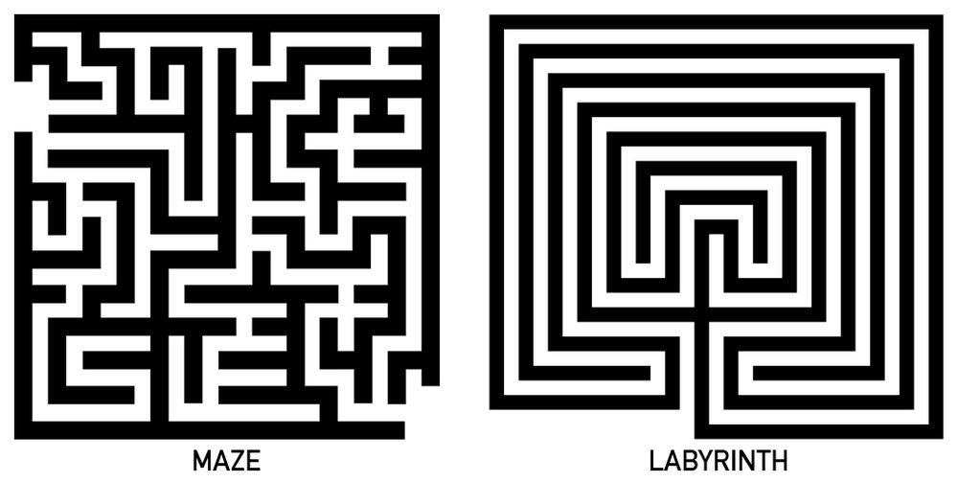

There are two types of mazes, a perfect maze and an imperfect maze. A perfect maze is defined as a maze that only has exactly one solution, while an imperfect maze has branches and contains multiple solutions. This means while perfect mazes contain unique paths, imperfect mazes can contain loops or paths that intersect with each other.
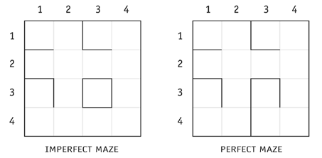
Our maze is an imperfect maze puzzle consisting of a grid with paths and walls, where the goal is to navigate from a start point to an endpoint. In this project, we focus on 3 different maze sizes: 10x10, 15x15, and 20x20, manageable yet complex sizes that allow for pathfinding challenges.

Problem Description
Since imperfect mazes have many different solutions, using conventional algorithms such as BFS would not always yield the most efficient solution. Therefore we need an algorithm with a heuristic function to find the most efficient solution amongst others.

Solution
This is where Dijkstra’s Shortest Path algorithm becomes useful. Dijkstra was invented by a Dutch computer scientist named Edsger W. Dijkstra in 1956. Dijkstra's algorithm is a greedy algorithm used to find the shortest path from a single source node to all other nodes in a weighted graph with non-negative edge weights. It works by iteratively selecting the closest unvisited node and updating the distances to its neighbors.

Dijkstra’s Algorithm pseudocode:

// Step 1: Initialization
create distance map dist, set all nodes to INFINITY
dist[source] = 0

create a min-priority queue Q
add all nodes to Q with their dist values

// Step 2: Main Loop
while Q is not empty:
u = node in Q with smallest dist[u]
remove u from Q

for each neighbor v of u:
alt = dist[u] + weight(u, v)
if alt < dist[v]:
dist[v] = alt
update priority of v in Q to dist[v]

return dist

The user is able to create their maze (set walls, start, and end points wherever they like) and the program will show the shortest possible solution or show that there is no solution (if there is none).

Functional Requirements
- Primitive Data:
- int rows;
- int cols;...
- Objects and Classes: Node, MazeHashmap, Solver classes..
- Imported classes:
- java.util.ArrayList,
- java.util.HashMap,
- java.util.HashSet,
- java.util.LinkedList
- java.util.PriorityQueue
- Custom Methods:
- solveMazeWithTimer(),
- traceBackPath()...
- Java Collections:
- HashMap
- PriorityQueue
- ArrayList
- Exception Handling:
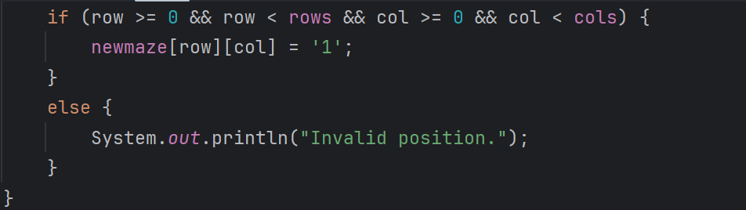

UML Diagram:
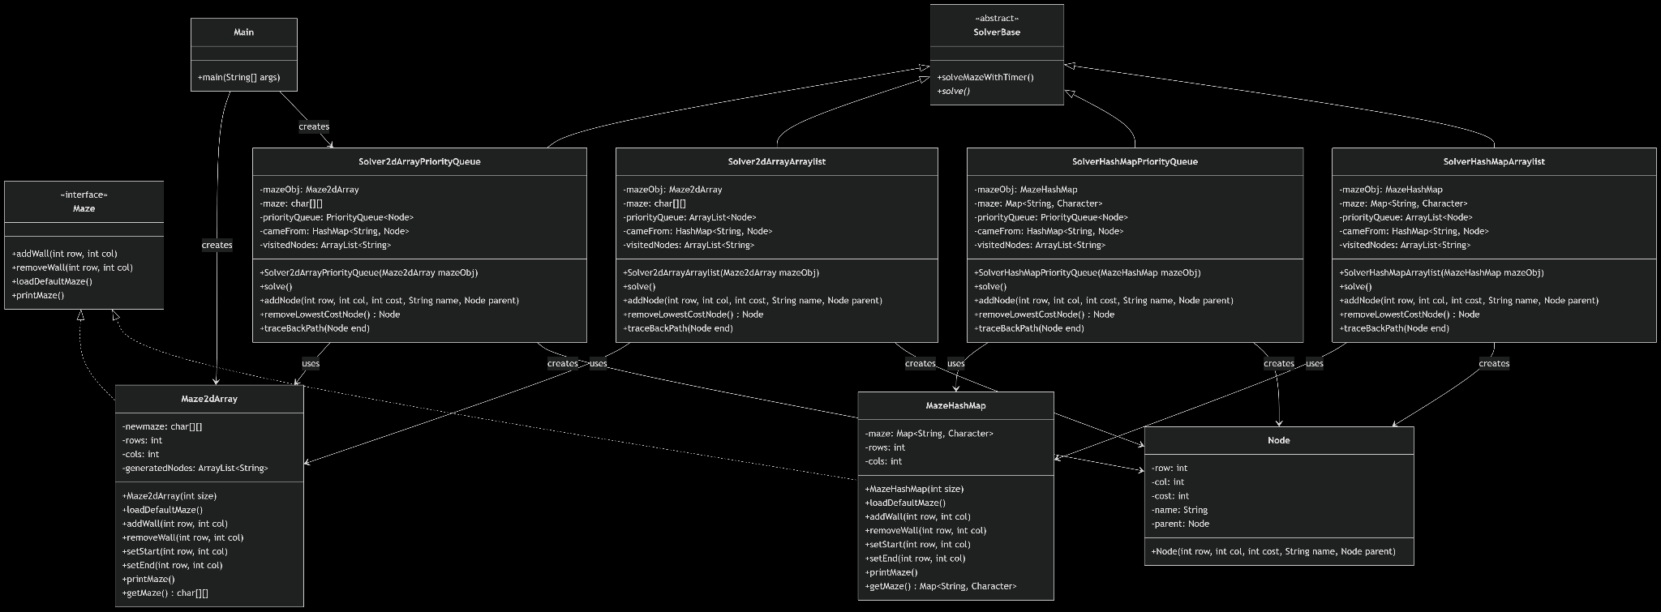

How the algorithm works:
- Initialize.
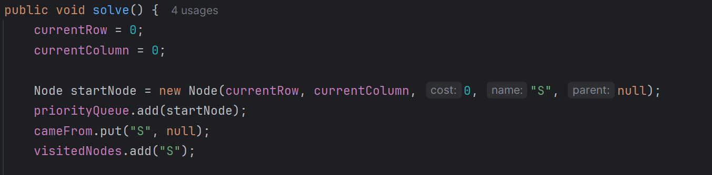
- The start node is always set at row 0 column 0.
- Creates a Node object with the currentRow: 0, currentColumn: 0, name: ‘S’ , and null as parent.
- Adds it to the queue

- Main loop: search for path
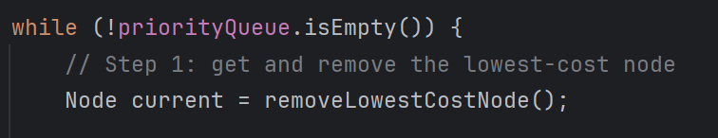
- From the current set of nodes in the priority queue, it chooses the lowest cost one.
- For the arraylist version, the removeLowestCostNode function has to iterate through every element in the arraylist, in order to find the lowest cost node:
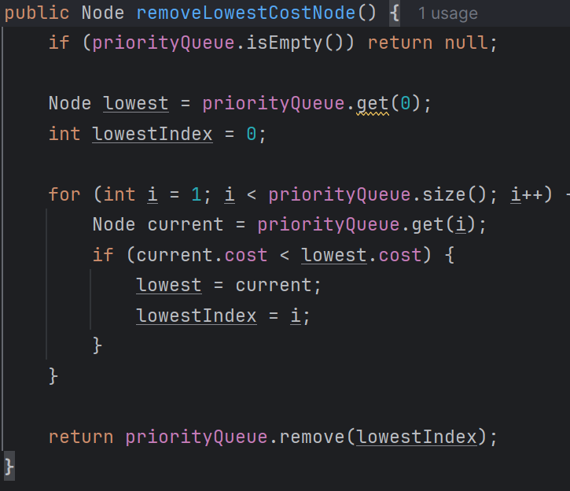
- Whereas in the actual priorityqueue implementation, the method is much simpler:

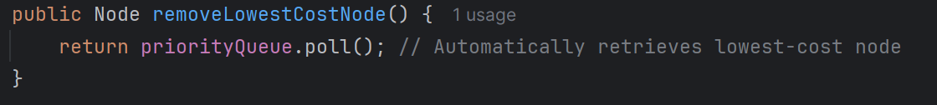

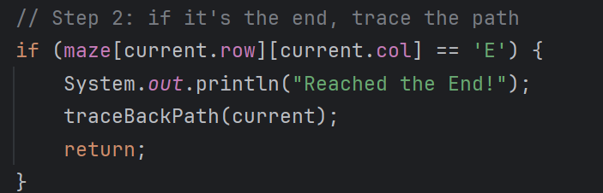
- It also checks if it reaches the end, ‘E’, if so it will trace back the path from E to S, if not, continue.

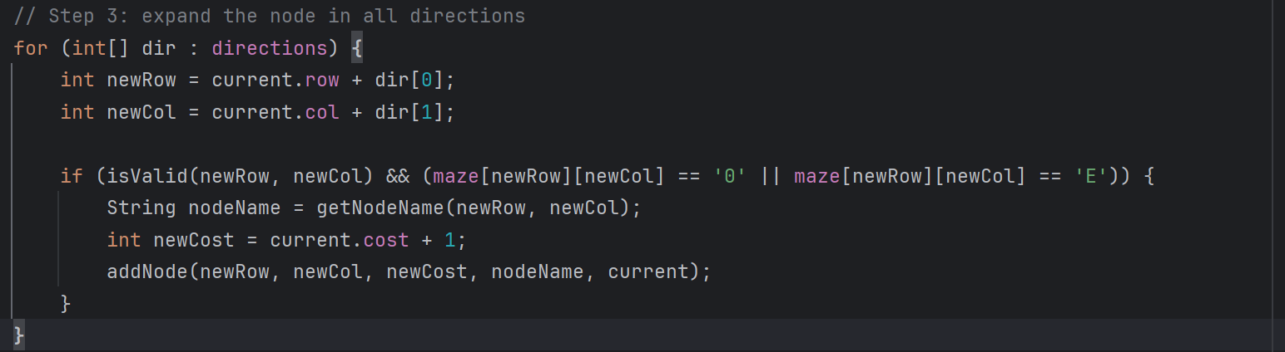
- It then expands the node in 4 directions while also checking if the move is valid (within bounds and not a wall)
- If the direction is valid, it will increase the cost by 1 and add the new node into the queue with information such as coordinates, cost, name, and parent.)

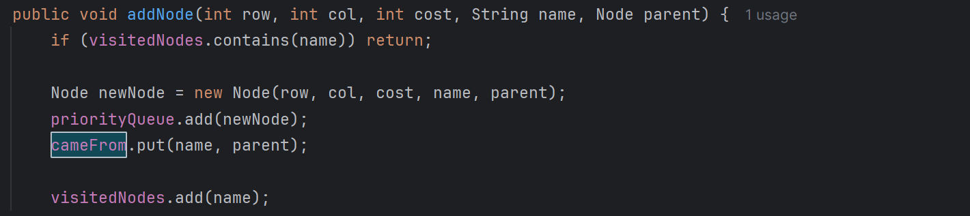
- When addNode is called, the name of the current node and the name of its parent is added to the cameFrom hashmap. It looks something like this {nodeName : parentName}
Here the name is key and parent is the value.

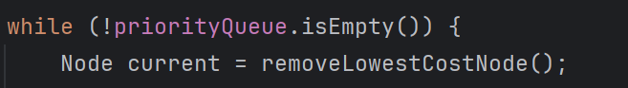
- Once it has explored all 4 directions and none of them are the end point, as long as the priority queue is not empty, the current node will be set to the node with the lowest cost, while simultaneously removing that node from the queue.
- Thus, from that new current node it will explore all 4 directions again.

- Traceback when we have reached the end.
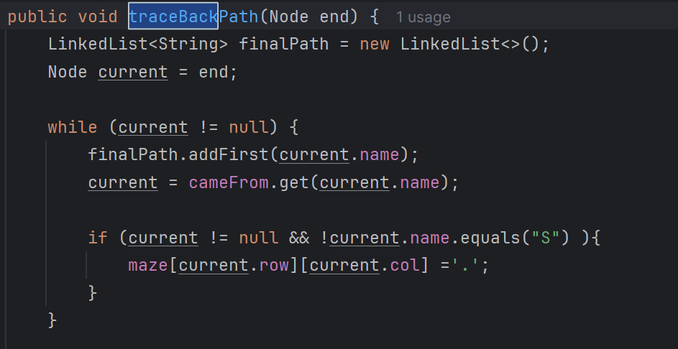
- Once the end is reached, a linked list is created and the node names are added from the cameFrom hashmap by accessing the value, which is the name of the parent node.
- This way, only the correct and shortest path is added to the finalPath.

How to use:
- In Main, there are 2 ‘warm up’ runs before actually calculating the time taken to execute solve(). This is because Java uses a JIT compiler, which optimizes code only after it's run a few times. Initial runs are slower, so warm-up executions are done first to ensure accurate performance measurements after JVM optimization.
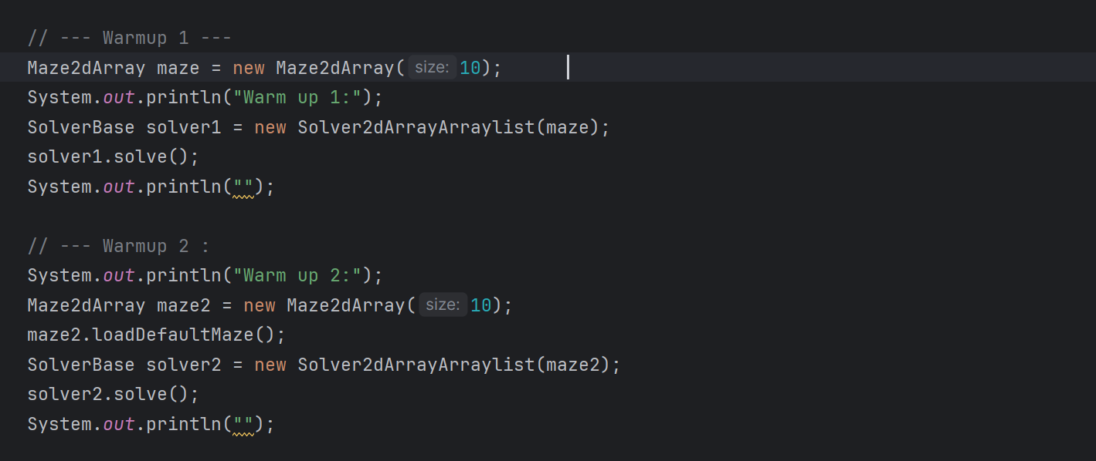

- In order to run the program, the user must create a new maze object based on their desired maze data structure (either Maze2dArray or MazeHashMap), while also inputting the desired size (10, 15 or 20)
- The user can either create a custom maze from zero by using addWall(row,col) and removeWall(row,col) or load a prebuilt maze based on the size by calling loadDefaultMaze() (addwall and removewall can still be used to modify the default maze)
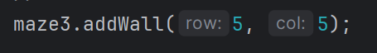
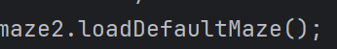
- The user should create a new solver object based on the desired solver datastructures: Solver2dArrayArraylist, Solver2dArrayPriorityQueue, SolverHashMapArraylist, SolverHashMapPriorityQueue. In the parameter the user should put the name of the maze they want to solve.
- The user can now call solve() to solve the maze. Or solveMazeWithTimer() to solve the maze and calculate the time spent doing so.

Screenshots of working program:
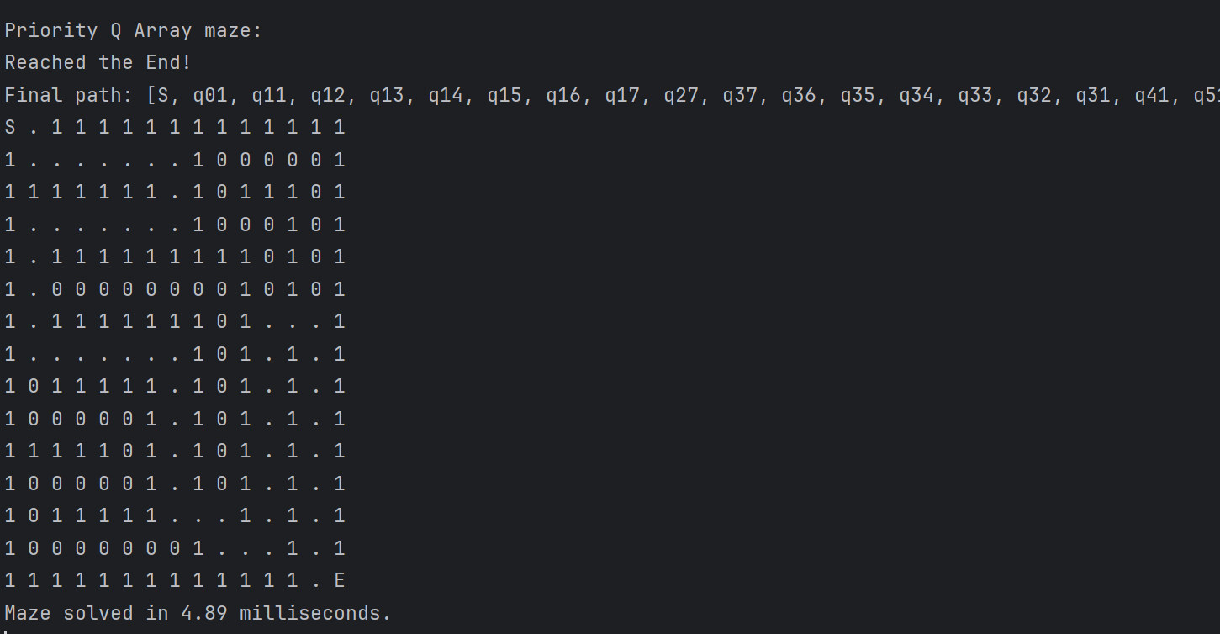

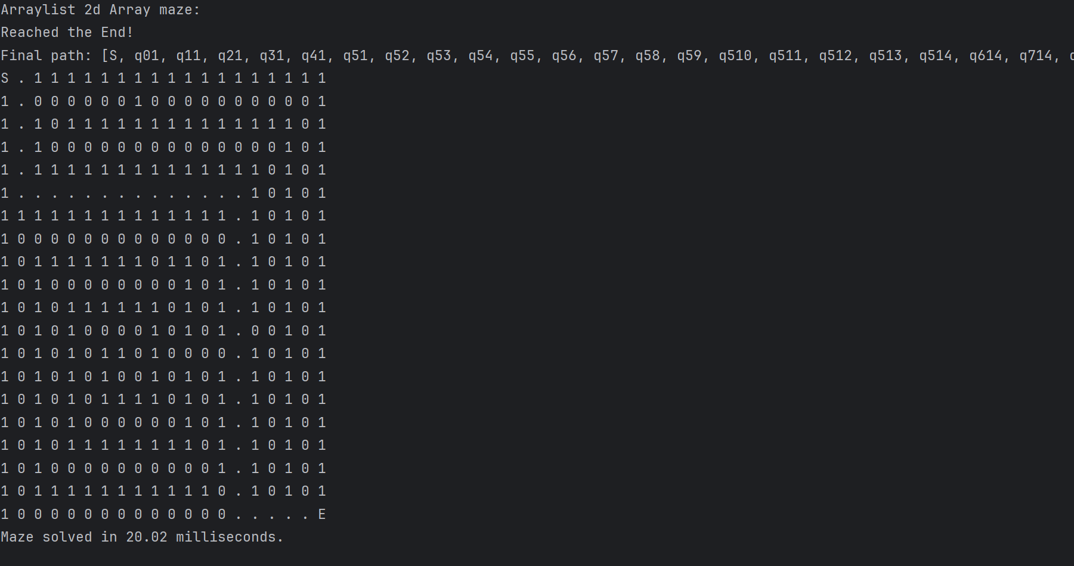

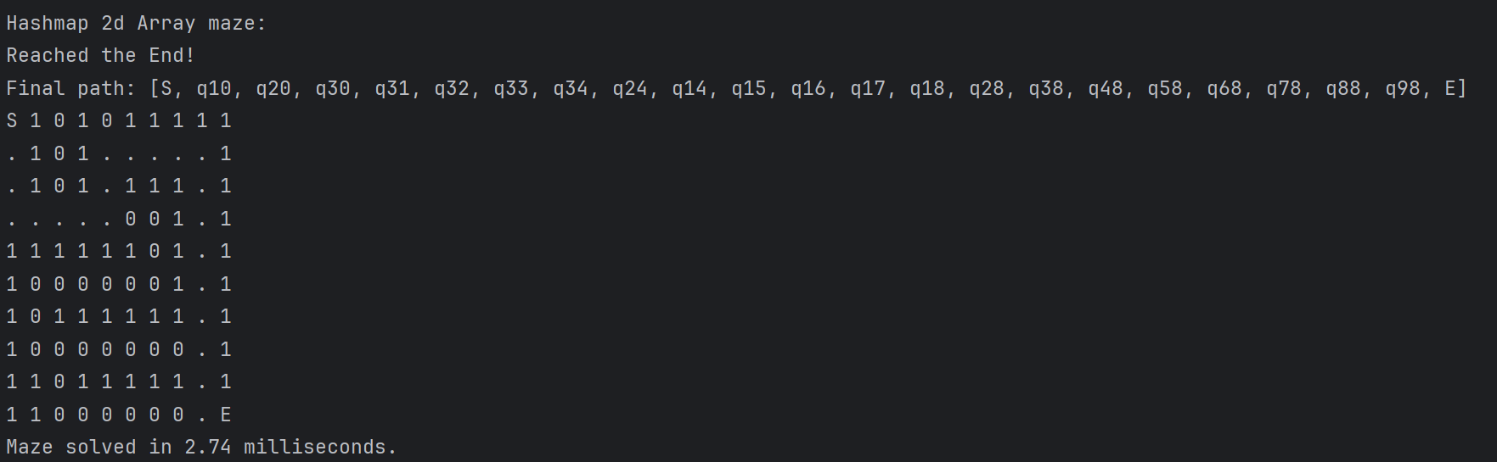

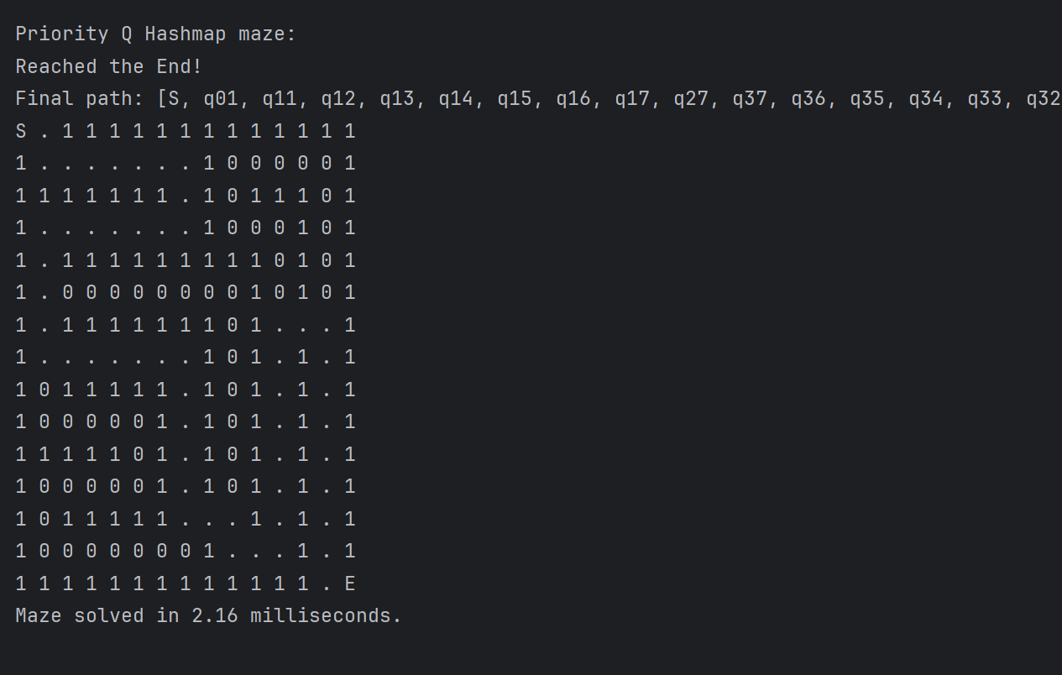

References

Buck, J. (n.d.). Mazes for Programmers: Code Your Own Twisty Little Passages. The Pragmatic Programmers LLC.

Dijkstra, E. W. (1976). A discipline of programming. Prentice Hall.

GeeksforGeeks. (2025, April 9). What is Dijkstra’s Algorithm? | Introduction to Dijkstra’s Shortest Path Algorithm. GeeksforGeeks. https://www.geeksforgeeks.org/introduction-to-dijkstras-shortest-path-algorithm/

Javaid, A. (2013). Understanding Dijkstra Algorithm. SSRN Electronic Journal. https://doi.org/10.2139/ssrn.2340905

Koffman, E. B., & Wolfgang, P. A. (2021). Data structures: abstraction and design using Java. -: John Wiley & Sons.

Weiss, M. A (2010). Data Structures and Problem Solving Using Java (Fourth Edition). -: Addison-Wesley.

